15-Oct-22

Abstract

Submitted in partial fulfillment of the requirements of the software engineering course

Software Requirements Specification

For Schneider Productivity Manager

### View statistical details

### 

|  |  |
| --- | --- |
| Property | Value |
| ID, Name | View statistical details |
| Include | Login |
| Goal | views statistical data of sorts for the user |
| Initiator | User |
| Precondition | * The user should be logged in |
| Postcondition | * The system will aggregate statistical analysis and send it to user |

#### Step-by-step Description

1. 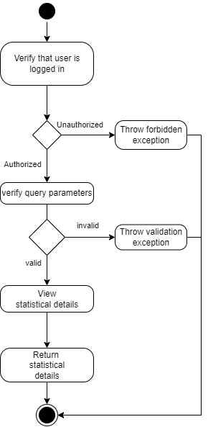The actor submits a view statistical details request.
2. The system runs validation checks, upon the failure of any,

throws an exception.

* 1. The system checks the actor’s login validity.
  2. The system verifies the query parameters of the request.

1. The system queries the database to get statistics data.
2. The system returns a response carrying a success code and the statistics data.

### View other projects

|  |  |
| --- | --- |
| Property | Value |
| ID, Name | View other projects |
| Include | Login |
| Goal | views data of other projects for the user |
| Initiator | User |
| Precondition | * The user should be logged in |
| Postcondition | * Other projects data is returned to the user if found |

#### Step-by-step Description

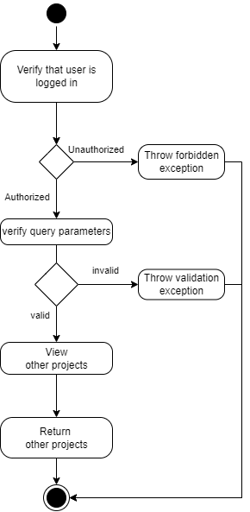

1. The actor submits a view other projects request.
2. The system runs validation checks, upon the failure of any,

throws an exception.

* 1. The system checks the actor’s login validity.
  2. The system verifies the query parameters of the request.

1. The system queries the database to get projects data.
2. The system returns a response carrying a success code

and other projects data.

### view all employees

|  |  |
| --- | --- |
| Property | Value |
| ID, Name | View all employees |
| Include | Login |
| Goal | views data of other employees for the user |
| Initiator | User |
| Precondition | * The user should be logged in |
| Postcondition | * Other employees data is returned to the user if found |

#### Step-by-step Description

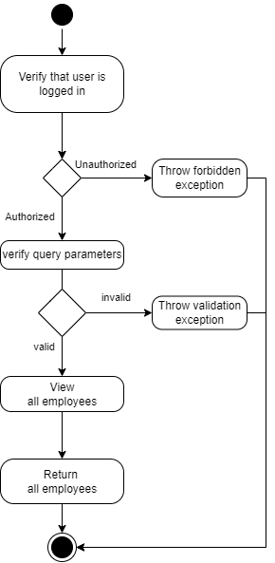

1. The actor submits a view all employees request.
2. The system runs validation checks, upon the failure of any,

throws an exception.

* 1. The system checks the actor’s login validity.
  2. The system verifies the query parameters of the request.

1. The system queries the database to get employees data.
2. The system returns a response carrying a success code

and all employees data.

## Non-Functional Requirements